4.6 Adv Graphing Quadratic Functions EXAM V1 Name:____________________________
- $y=x^{2}-4x-5$ |  | opens up or down? | 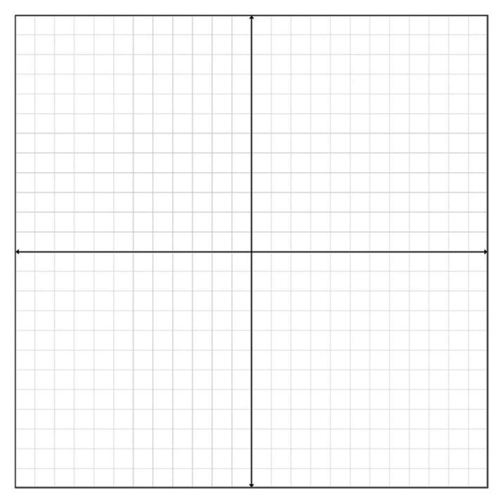
Vertex: | Max/Min | axis of symmetry
Vertex Form:

x intercept(s):

y-intercept:

 |  |  | Range | Domain:
Scratch work:

2. $y=-x^{2}-2x-3$ |  | opens up or down? | 
Vertex: | Max/Min | axis of symmetry
Vertex Form:

x intercept(s):

y-intercept:

 |  |  | Range | Domain:
Scratch work:

3. A football is punted into the air. Its height h, in meters, after t seconds is given by the equation
h =$-16t^{2}+80t+3$
- How high was the ball when it was punted?

- How high is the ball after 2 seconds?

- Find the maximum height of the ball to one decimal place.

- When does the ball reach its maximum height? (round your answer to one decimal place.)

- When does the ball hit the ground?

4. List the transformations for the following Quadratic:
$f(x)=-\frac{1}{4}(x+3)^{2}-1$
_______________________________________________________________________________

4.6 Graphing Quadratic Functions EXAM V2 Name:____________________________
- $y=x^{2}-4x-5$ |  | opens up or down? | 
Vertex: | Max/Min | axis of symmetry
Vertex Form:

x intercept(s):

y-intercept:

 |  |  | Range | Domain:
Scratch work:

2. $y=-x^{2}-2x-3$ |  | opens up or down? | 
Vertex: | Max/Min | axis of symmetry
Vertex Form:

x intercept(s):

y-intercept:

 |  |  | Range | Domain:
Scratch work:

3. A football is punted into the air. Its height h, in meters, after t seconds is given by the equation
h =$-16t^{2}+80t+3$
- How high was the ball when it was punted?

- How high is the ball after 2 seconds?

- Find the maximum height of the ball to one decimal place.

- When does the ball reach its maximum height? (round your answer to one decimal place.)

- When does the ball hit the ground?

4. List the transformations for the following Quadratic:
$f(x)=-\frac{1}{4}(x+3)^{2}-1$
_______________________________________________________________________________

